This needs to be the same on ours rs dropdown, counts, statute type, and as many charges as you need.
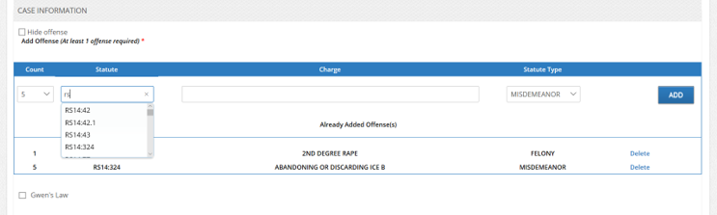
We need to add these options to our text box, and text area boxes
See how the changes are entered into the warrant
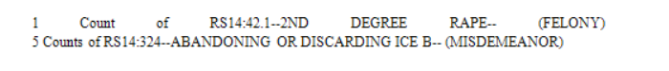
Here are how they are listed in the bond for judge to set,
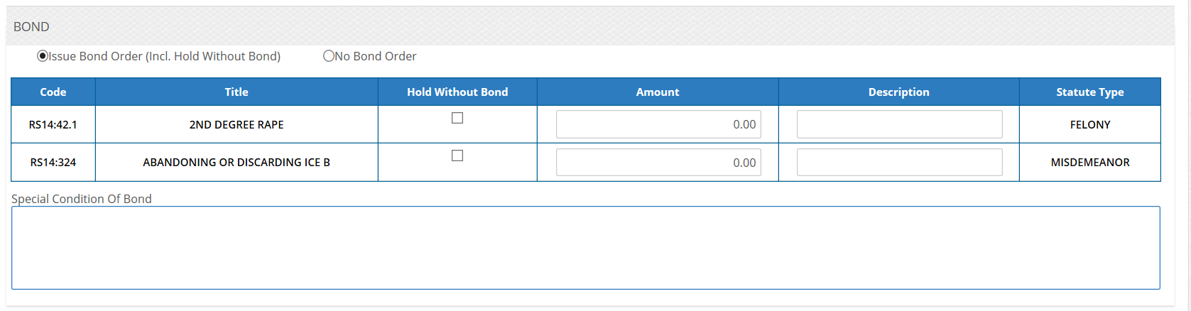
This is how they look on the bond sheet
